Question 9 [6 Points]

Write a C program to demonstrate zombie process prevention.
• Create multiple child processes
• Ensure terminated child processes do not remain zombies
• Parent process should print the PID of each child it cleans upUse fork(), wait(), or waitpid().
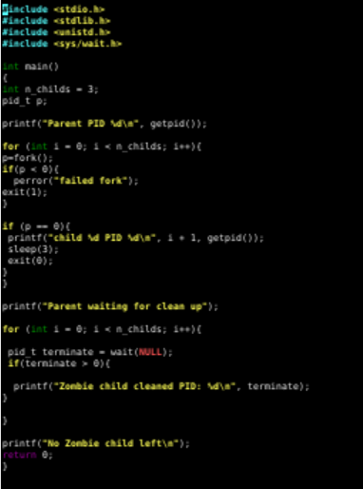

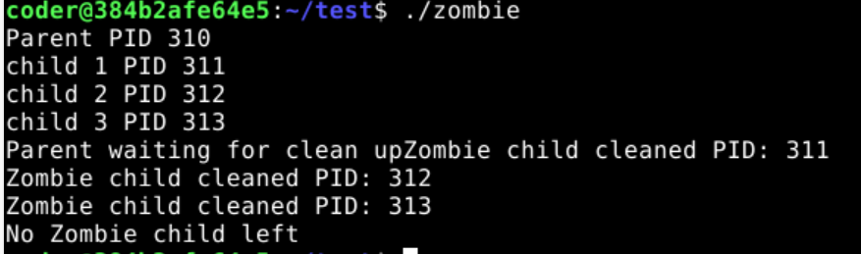
Explanation: Above script creates multiple child process using for loop and wait. Upon that we terminated all child zombie process one by one and at the end none left.

